Design Document for ABC Asset Management Fund Fact Sheet Generator

Project ID
Project Name | ABC Asset Management Fund Fact Sheet Generator
Account
Business Unit / Global Account
Project Manager
Document Version Number | 1.0.0

Revision History
Version Number | Release Date | Description of Change/s made | Author  (Name & Role) | Reviewer  (Name & Role) | Approver  (Name & Role)
 | Mmm-DD-YY

Table of Contents
Revision History 2
1. Introduction 4
1.1 Purpose 4
1.2 Scope 4
1.3 Definitions, Acronyms and Abbreviations 4
1.4 References 4
2. System Architecture 5
2.1 Overview 5
2.2 High-Level System Architecture Diagram 5
3. Functional Design 6
3.1 Data Flow Diagram 6
3.2 Functionality 6
3.3 Report Layout………………………………………………………………………………………………….7
4. Database Design 8
4.1 ER-Diagram……………………………………………………………………………………………………8
4.2 Database Environment……………………………………………………………………………………….9
4.3 Naming Convention…………………………………………………………………………………………..9
4.4 Database Schema…………………………………………………………………………………………….9
5. User Interface Design 13
5.1 Screen Flow Hierarchy 13
5.2 Screen Design 13
6. Environment 20
6.1 Development Environment 20
6.1.1 Hardware Details 20
6.1.2 Operating Environment 20
6.2 Production Environment 20
6.2.1 Hardware Details 20
6.2.3 Operating Environment 20
7. Design Issues and Solution 20

Introduction
ABC Asset Management (ABC) is one of Singapore’s oldest investment companies, created in 1968. ABC manages $20 Billion of assets, making it the largest active manager in Singapore. As a leading global asset manager, ABC is dedicated to creating long-term value for their clients. The investment needs of their clients are at the heart of what they do. ABC’s customers now need a daily fund fact sheet.

1.1 Purpose
The purpose of the Design Document is to ensure that every component meets its performance requirements as stated by ABC company. This document considers the necessary data needed to produce a daily fund fact sheet, as well as creating a web application.

1.2 Scope
ABC daily fund fact sheet generator will generate a fund fact sheet and email to investors and company everyday. The fund details and fund manager details are configurable. It will generate fact sheets for both Prestige and Global market. It will display performance overview, sector allocation, top five holdings and fund details.

1.3 Definitions, Acronyms and Abbreviations
- SGX - Singapore Exchange Limited
- NYSE - New York Stock Exchange
- Bid-Bid – Growth of bid value from stated time to current time
- Offer-Bid – Current offer value to bid value of stated time
- Benchmarks – unmanaged group of securities which are used to measure a fund's/stock's performance
- NAV - The net asset value (NAV) represents the net value of an entity and is calculated as the total value of the entity’s assets minus the total value of its liabilities

1.4 References

- https://sg.finance.yahoo.com/
- https://www.nyse.com/index
- https://www2.sgx.com/

System Architecture

2.1 Overview
The daily fund fact sheet generator system has been developed as a web application. Client side is written in C#. Client can access the system through the web which communicates with the server database hosted locally using MySQL.

2.2 High-Level System Architecture Diagram

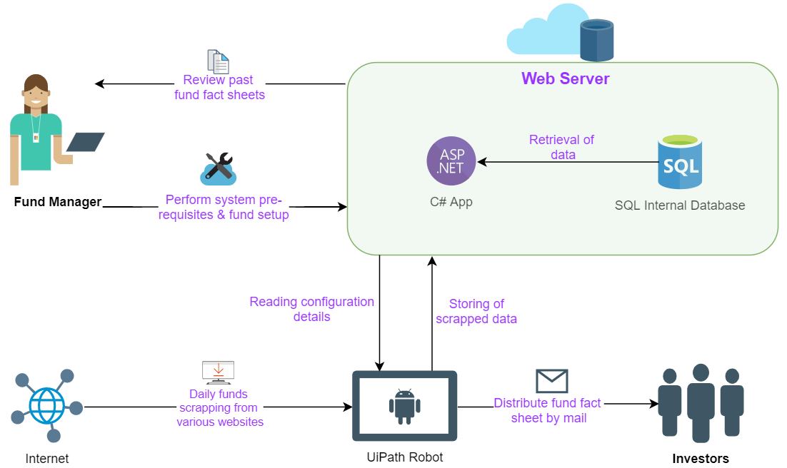

Functional Design

3.1 Data Flow Diagram
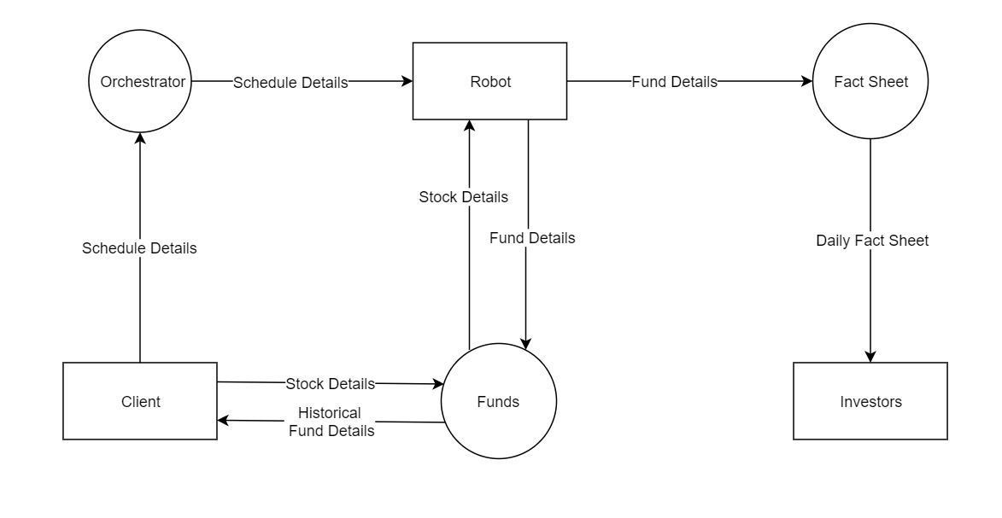

Functionality

Component | Functionality
3.2.1 Login | The program unit will allow only authorized users (i.e. fund manager) to login.
3.2.2 Main | The program unit will allow the user to navigate to different pages. He can search past fact sheets, edit fund details, edit company’s info and edit investor’s list.
3.2.3 Edit Fund Details | The program unit will allow the user to edit various fund details.
3.2.4 Search Fact Sheet | The program unit will allow the user to search past fund fact sheet, if it exists.
3.2.5 Edit Investor’s List | The program unit will allow the user to edit the mailing list of investors.
3.2.6 Edit Company’s Info | The program unit will allow the user to edit various stock’s details.
3.2.6 Web Scrapping | The program unit is an automated process that will web scrape the internet daily for relevant fund information.
3.2.7 Pdf Generation | The program unit is an automated process that will generate pdfs daily.
3.2.7 Send Email | The program unit is an automated process that send emails to relevant investors.

3.3 Report Layout of Generated PDF
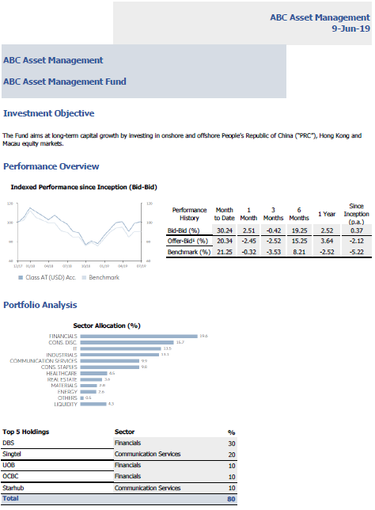
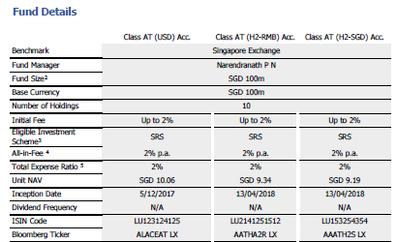

Database Design

4.1 Database Model (ER-Diagram)
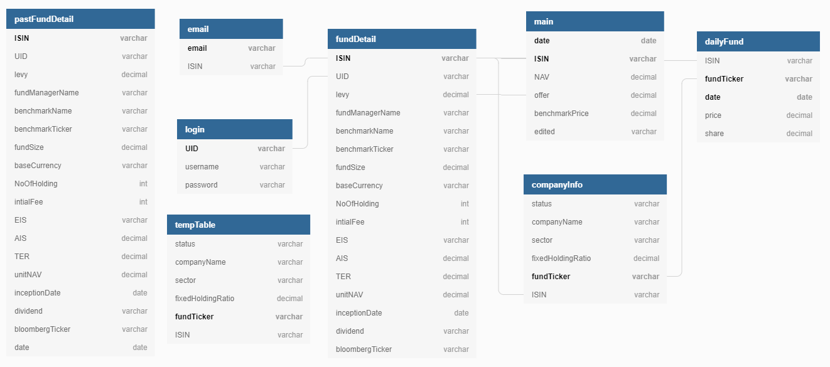

4.2 Database Environment

Hardware

4.2GB disk space, 4GB of RAM, Intel-compatible processor with 1 GHz or faster processor.

Software

SQL Server 2014 Management Studio
S.S.M.S. Ver 12.0
Supported operating systems include Windows 10, 7 and 8, Windows Server 2008 R2 and Windows Server 2012

4.3 Naming Convention

- Singular names for tables
- Singular names for columns
- Schema name for tables prefix (E.g.: schemeName.tableName)
- Camel casing (E.g. baseCurrency)

4.4 Database Schema

email
Field Name | Data type | Size | Constraints | Remarks
email | Varchar | 50 | Primary Key
ISIN | Varchar | 50

login
Field Name | Data type | Size | Constraints | Remarks
UID | Varchar | 50 | Primary Key
username | Varchar | 50
password | Varchar | 50

fundDetails
Field Name | Data type | Size | Constraints | Remarks
ISIN | Varchar | 50 | Primary Key | Composite
date | Date |  | Primary Key | Composite
UID | Varchar | 50 | Foreign Key
levy | Varchar | 50
benchmarkName | Varchar | 50
benchmarkTicker | Varchar | 50
fundManagerName | Varchar | 50
fundSize | Decimal | 18,0
baseCurrency | Varchar | 50
noOfHolding | Int
initialFee | Int
EIS | Varchar | 50
AIS | Decimal | 18,0
TER | Decimal | 18,0
unitNAV | Decimal | 18,2
inceptionDate | Date
dividend | Varchar | 50
bloombergTicker | Varchar | 50

pastFundDetails
Field Name | Data type | Size | Constraints | Remarks
ISIN | Varchar | 50
date | Date
UID | Varchar | 50
levy | Varchar | 50
benchmarkName | Varchar | 50
benchmarkTicker | Varchar | 50
fundManagerName | Varchar | 50
fundSize | Decimal | 18,0
baseCurrency | Varchar | 50
noOfHolding | Int
initialFee | Int
EIS | Varchar | 50
AIS | Decimal | 18,0
TER | Decimal | 18,0
unitNAV | Decimal | 18,2
inceptionDate | Date
dividend | Varchar | 50
bloombergTicker | Varchar | 50

dailyFund
Field Name | Data type | Size | Constraints | Remarks
date | Date |  | Primary Key | Composite
fundTicker | Varchar | 50 | Primary Key | Composite
ISIN | Varchar | 50 | Foreign Key
price | Decimal | 18,0
share | Decimal | 18,0

main
Field Name | Data type | Size | Constraints | Remarks
date | Date |  | Primary Key | Composite
ISIN | Varchar | 50 | Primary Key | Composite
NAV | Decimal | 18,2
Offer | Decimal | 18,2
benchmarkPrice | Decimal | 18,2
edited | Varchar | 50

companyInfo
Field Name | Data type | Size | Constraints | Remarks
fundTicker | Varchar | 50 | Primary Key
ISIN | Varchar | 50 | Foreign Key
status | Varchar | 50
companyName | Varchar | 50
sector | Varchar | 50
fixedHoldingRatio | Decimal | 18,0

temptable
Field Name | Data type | Size | Constraints | Remarks
fundTicker | Varchar | 50 | Primary Key
ISIN | Varchar | 50 | Foreign Key
status | Varchar | 50
companyName | Varchar | 50
sector | Varchar | 50
fixedHoldingRatio | Decimal | 18,0

User Interface Design

5.1 Screen Flow Hierarchy
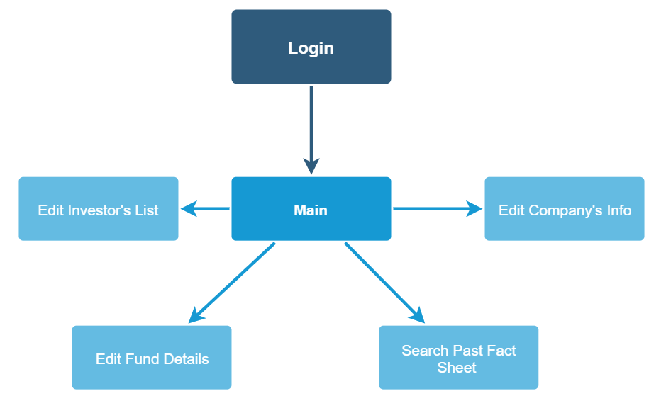

Screen Design
5.2.1 Login page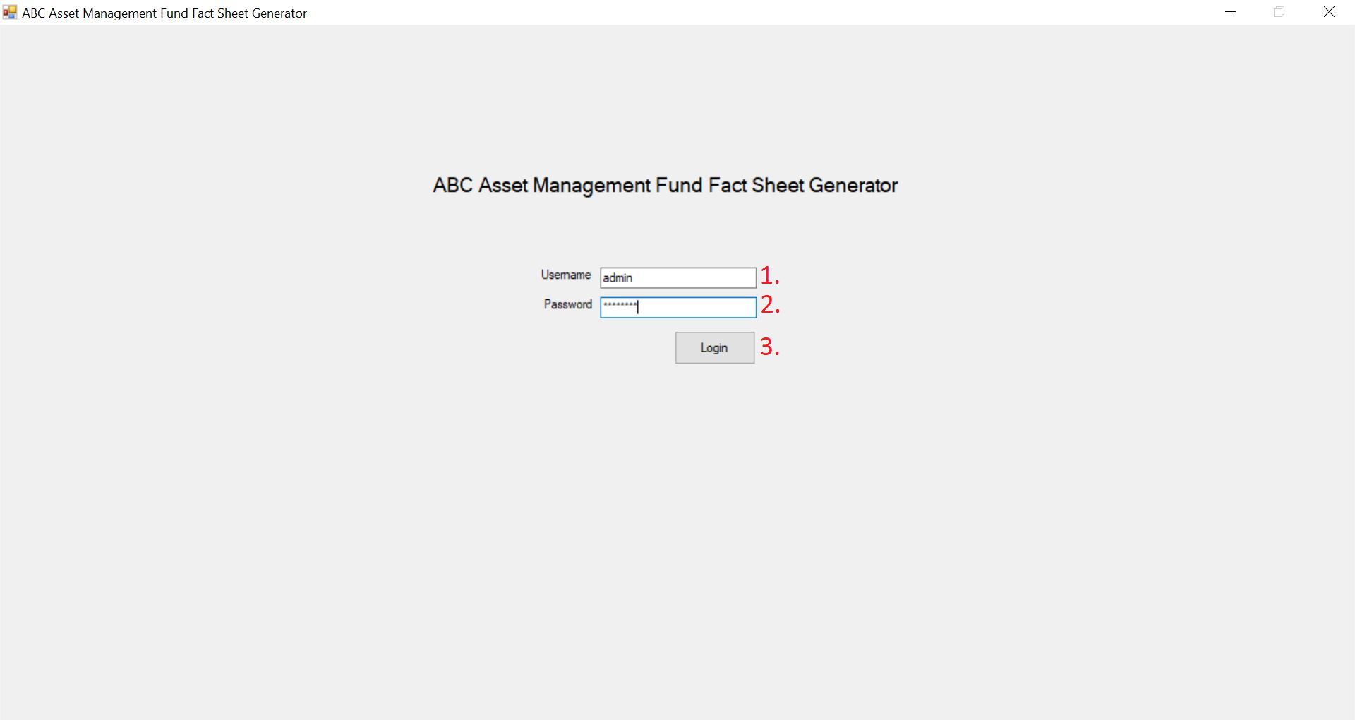

      - Username
There will be an empty text box for fund manager to input his user name.
      - Password
There will be an empty text box for fund manager to input his password. Inputted characters will be hidden.
      - Login Button
After inputting the correct username and password, the fund manager will click login to enter the main page. A popup will appear on input of incorrect username/password combination.
    - Main Page 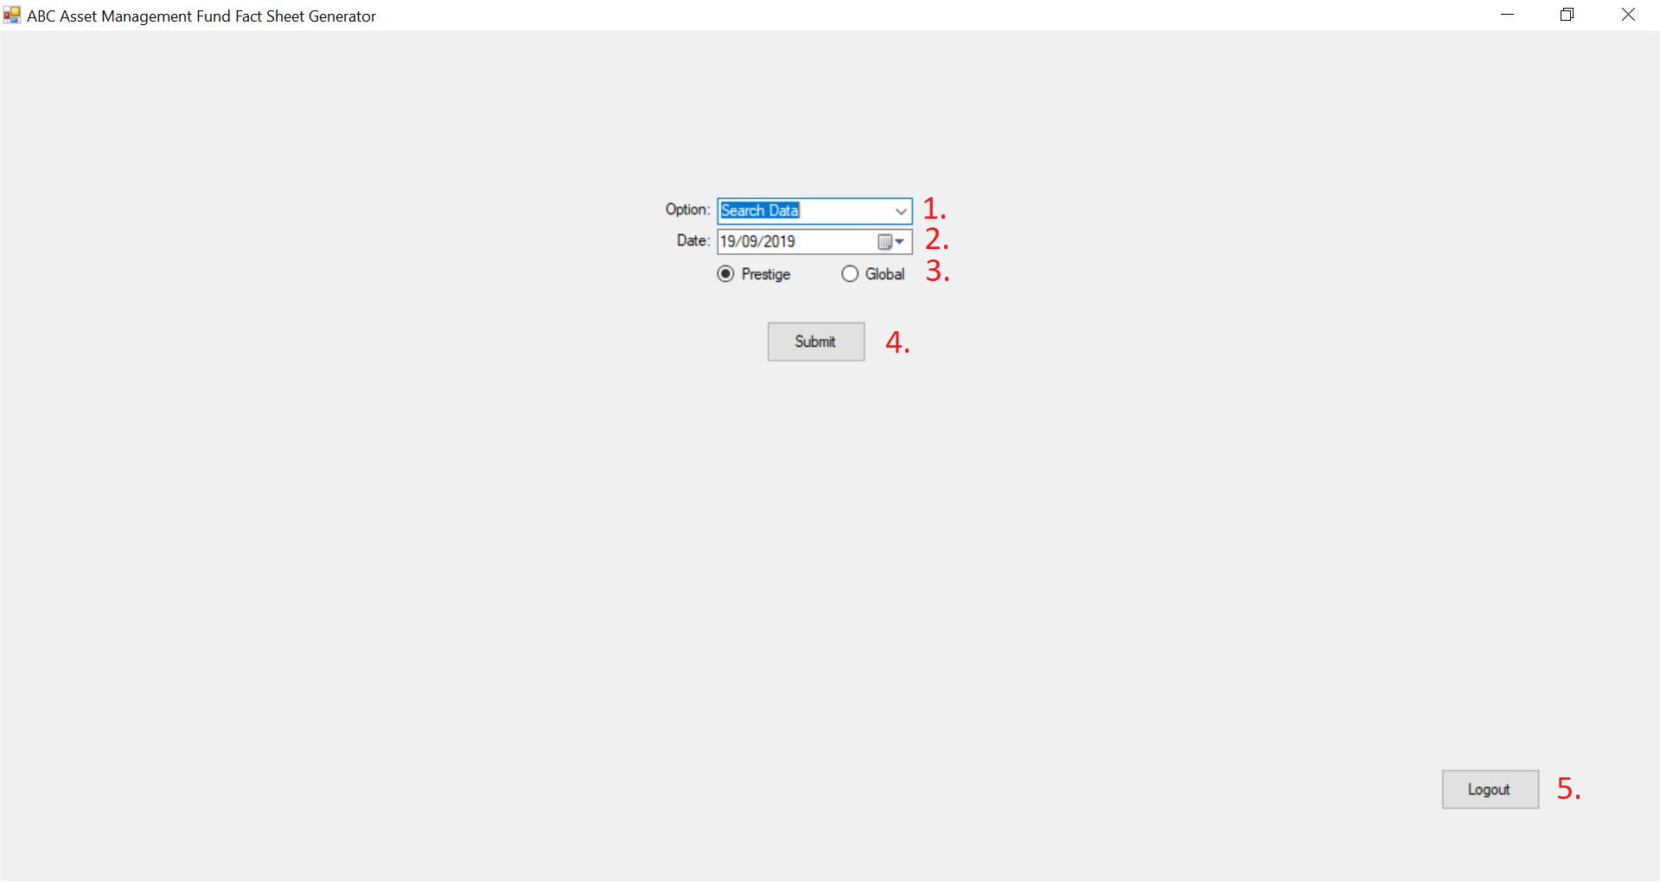
      - Option
There will be a drop-down button allowing the fund manager to choose between “Search Past Fact Sheet”, “Edit Fund Details”, “Edit Investor’s List” and “Edit Company’s Info”
      - Date
This option will only appear if the fund manager chooses “Search Past Fact Sheet”. The fund manager will be able to key in the desired data either through typing in the box or by clicking on the calendar icon. A calendar will pop out should this option be chosen.
      - Region
There will be a radio button allowing the fund manager to choose between “Prestige” and “Global”.
      - Submit Button
After keying all the fields, the fund manager will be able to click on submit to enter the desired page. A pop-up will appear if entries are invalid or data was unavailable for the specified date.
      - Logout Button
There is also a logout button at this point should the fund manager wish to discontinue using the app.
    - Search Fact Sheet Page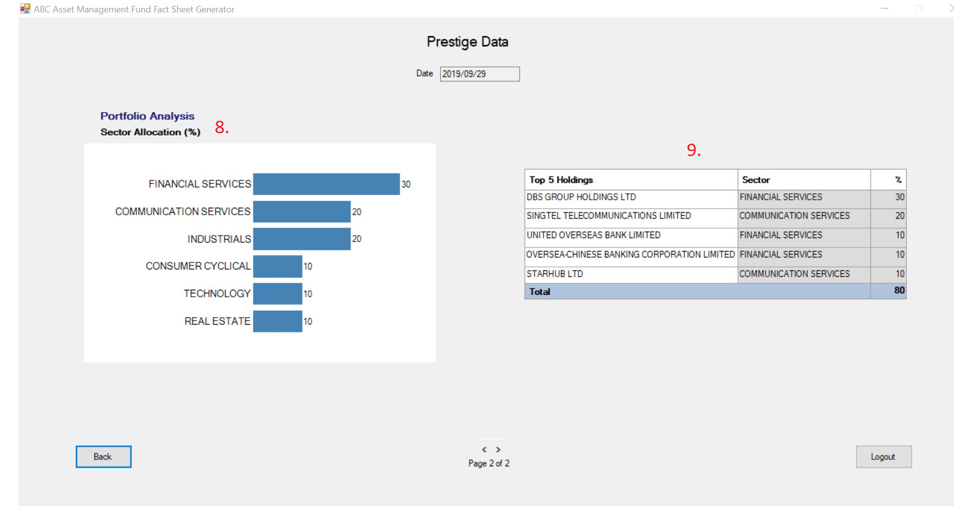
      - Region
There will be an indicator showing the fund manager which region the fund is for.
      - Date
There will be an indicator showing the fund manager which date the fund history is showing
      - Performance Overview
There will be a chart showing the performance overview of the fund for the bid-bid pricing. The benchmark will be included as well.
      - Bid-Bid Table
There will be a table showing the performance history for bid-bid, offer-bid as well as benchmark. The dates are marked against various time periods of year-to-date, 1 month, 3 month, 6 month, 1 year as well as since inception.

      - Back Button
There will be a back button for when the fund manager would want to return to the main menu page.
      - Navigation
The fund manager will be able to navigate through different pages through the navigation panel.
      - Logout Button
There will be a logout button should the fund manager wishes to discontinue using the app.
      - Portfolio Analysis
There will be a portfolio analysis histogram that shows the different sector allocation.
      - Top 5 Holdings
There will be a table indicating the top 5 holdings. A second column will display the sector the holding is from while a third column will display the holding percentage.
    - Edit Company Info Page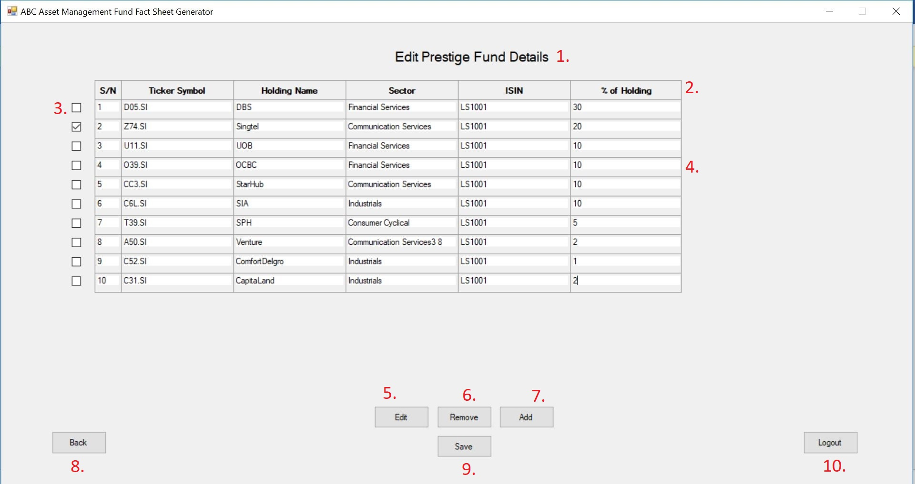
      - Title
There will be a title displaying which fund details are being edited. (e.g. Prestige)
      - Headings
There will be various headings indicating what each column represents
      - Checkboxes
There will be checkboxes to indicate which fund to perform an action on.
      - Entries
The entries will be editable if the edit function is performed after selecting the desired rows. All entries will be editable except for the first column (S/N)
      - Edit Button
The edit button will allow the user to edit selected funds.
      - Remove Button
The remove button will allow the user to remove selected funds.
      - Add Button
The add button will allow the user to add an empty row.
      - Save Button
The save button will allow the user to update and send the edited fund details to the database.
      - Back Button
The back button will allow the user to return to the main page.
      - Logout Button
The logout button will allow the user to exit the application.
    - Edit Investor’s List Page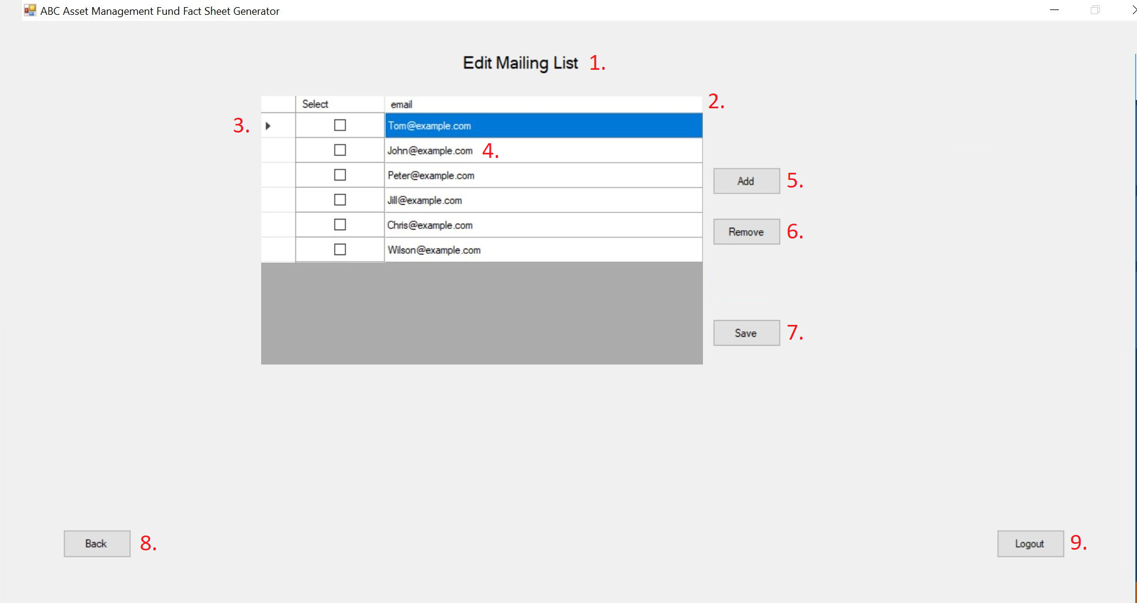
      - Title
There will be a title displaying email mailing list
      - Headings
There will be various headings indicating what each column represents
      - Checkboxes
There will be checkboxes to indicate which email to perform an action on.
      - Entries
The entries will be editable after performing an add fund to edit the email
      - Add Button
The add button will allow the user to add an empty row
      - Remove Button
The remove button will allow the user to remove selected rows
      - Save Button
The save button will allow the user to update and send the edited mailing list to the database.
      - Back Button
The back button will allow the user to return to the main page.
      - Logout Button
The logout button will allow the user to exit the application.

    - Edit Fund Details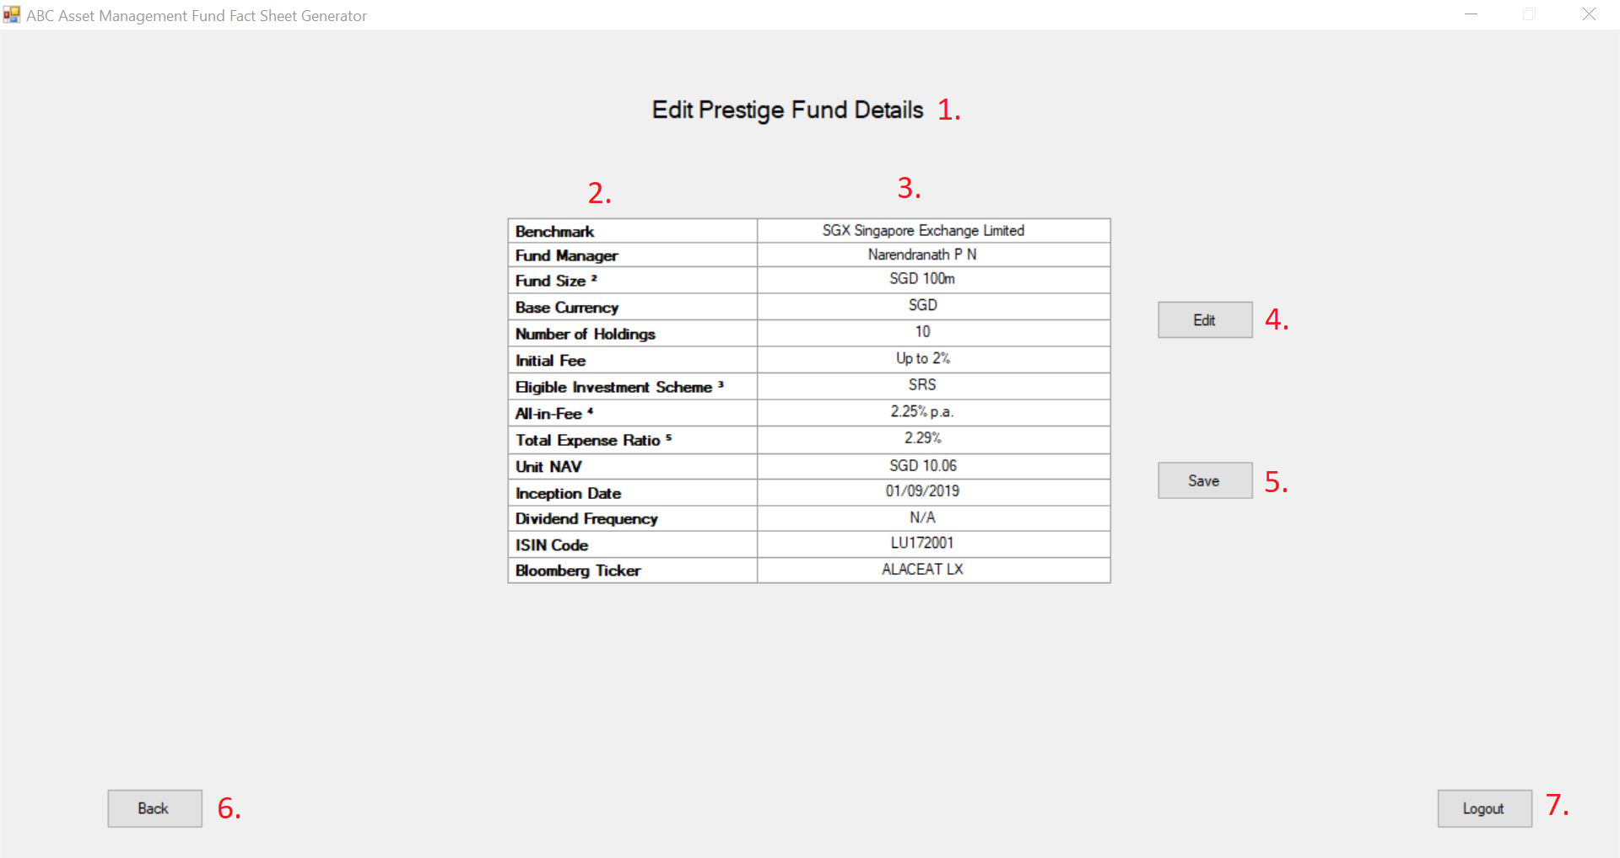
      - Title
There will be a title displaying the funds being edited.
      - Headings
There will be various headings indicating what each row represents.
      - Values
There will be values placed respectively to each row heading.
      - Edit Button
The edit button will allow the user to edit the entries.
      - Save Button
The save button will allow the user to update and send the edited fund details to the database.
      - Back Button
The back button will allow the user to return to the main page.
      - Logout Button
The logout button will allow the user to exit the application.

Environment

6.1 Development Environment

6.1.1 Hardware Details
The system will use the standard hardware and data communications resources provided by the client. This includes, the general Ethernet network connection at the hosting site. This system requires a minimum spec for the PC running the robot is as stated:
•CPU. 1.4GHz 32-bit (x86) Dual Core 1.8GHz 64-bit
•RAM. 4 GB or more etc.

6.1.2 Operating Environment
The system will use the standard software resources provided by the client.

Operating system: Windows 7 and above
.NET Framework: minimum: 4.6.1
Other Software: Excel 2000 and above, Adobe PDF, Chrome.

6.2 Production Environment

6.2.1 Hardware Details
The system will use the standard hardware and data communications resources provided by the client. This includes, the general Ethernet network connection at the hosting site. This system requires a minimum spec for the PC running the robot is as stated:
•CPU. 1.4GHz 32-bit (x86) Dual Core 1.8GHz 64-bit
•RAM. 4 GB or more etc.

6.2.2 Operating Environment
The system will use the standard software resources provided by the client.

Operating system: Windows 7 and above
.NET Framework: minimum: 4.6.1
Other Software: Excel 2000 and above, Adobe PDF, Chrome.

Design Issues and Solution
7.1 An enterprise account is needed to trigger a UiPath job via external application. This is due to the changes made by UiPath itself. As such, our clients would have to learn to schedule and trigger the job manually via the windows scheduler. Alternatively, our clients would have to take up a course on how to use UiPath Orchestrator.

Template Revision History (For EPEX Use Only)
Version Number | Release Date | Description of Change/s made | Author  (Name & Role) | Reviewer  (Name & Role) | Approver  (Name & Role) | QMS Release Version
1.0 | NA | Initial baseline | NA | NA | SEPG | NA
2.0 | Jun-14-11 | - Assigned artifact id, version #, release date to the template and modified Information Classification label in the footer  - Migrated to new template | Hemalatha Balasubramanyan, SEPG | Smita Koshy, SEPG | Rajesh Sreekumar, SEPG | 4.2
2.1 | Nov-30-18 | Modified SEPG references to EPEX as a part of Re-Org | Prakash Palaniswamy, EPEX | Pradeep Kumar Pullathil, HEAD, EPEX | Pradeep Kumar Pullathil, HEAD, EPEX | 7.5

